

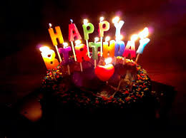

AQSA MOHSIN

INVITED BY:

**HOME**

LOCATION

**8:00 to 1:00 A.M**

**timings**

**2nd june**

**DATE**

**Birthday party**

**You are invited to celebrate**